Roman Cassman 1-22-2023

Lab2 – Defending the Network from a Simulated Attack (3e)

Part 1:

Question 14.

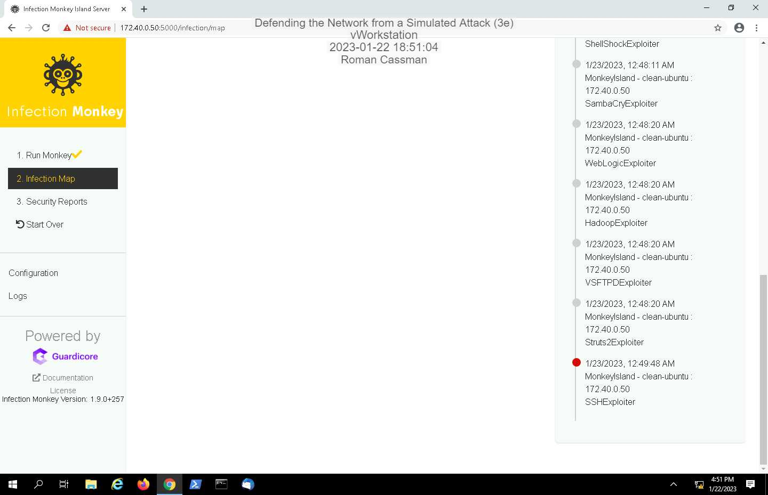

17.

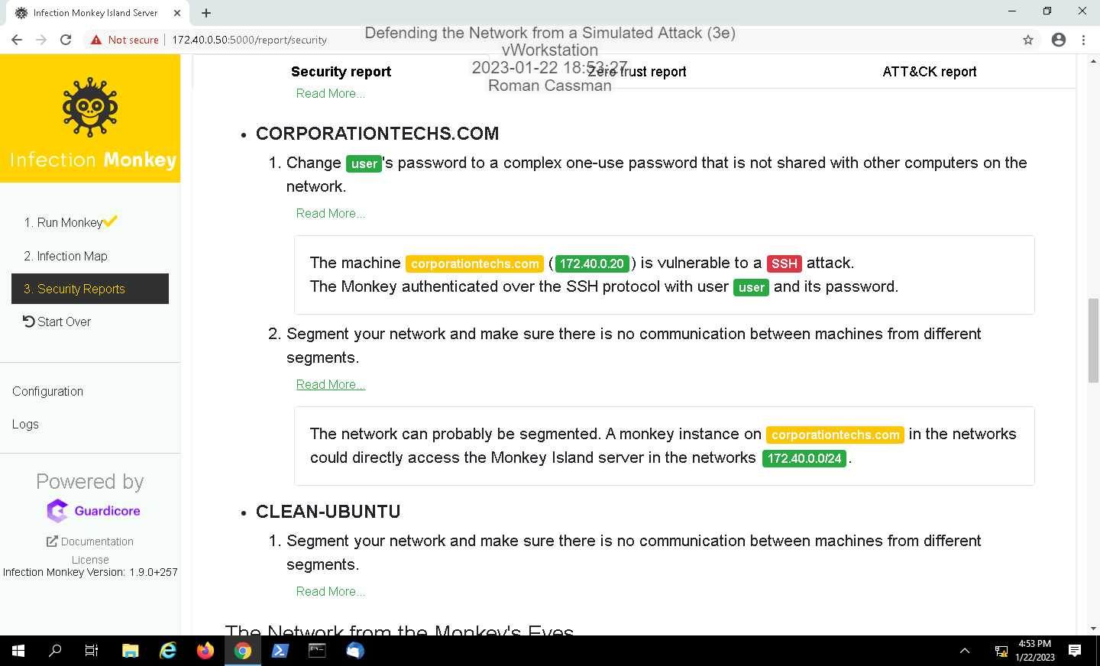

20.

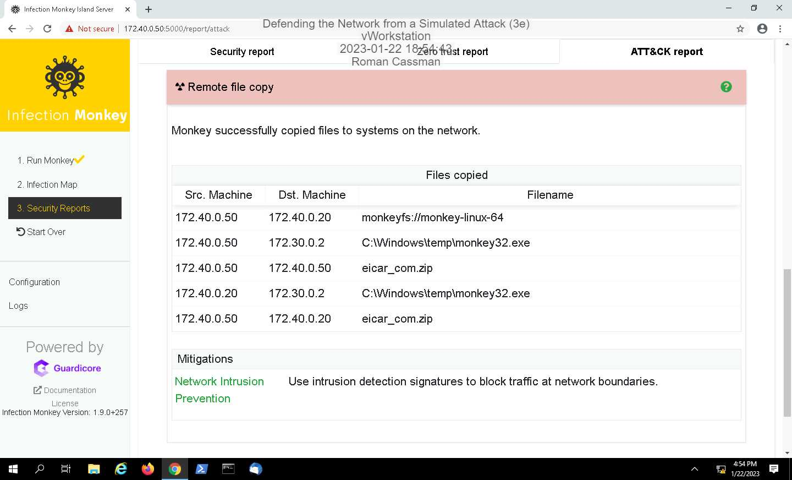

Part 2:

12.

